Linux Environment Variable Assignment

- State the command for the following.
  - view current environment variables
Ans: printenv
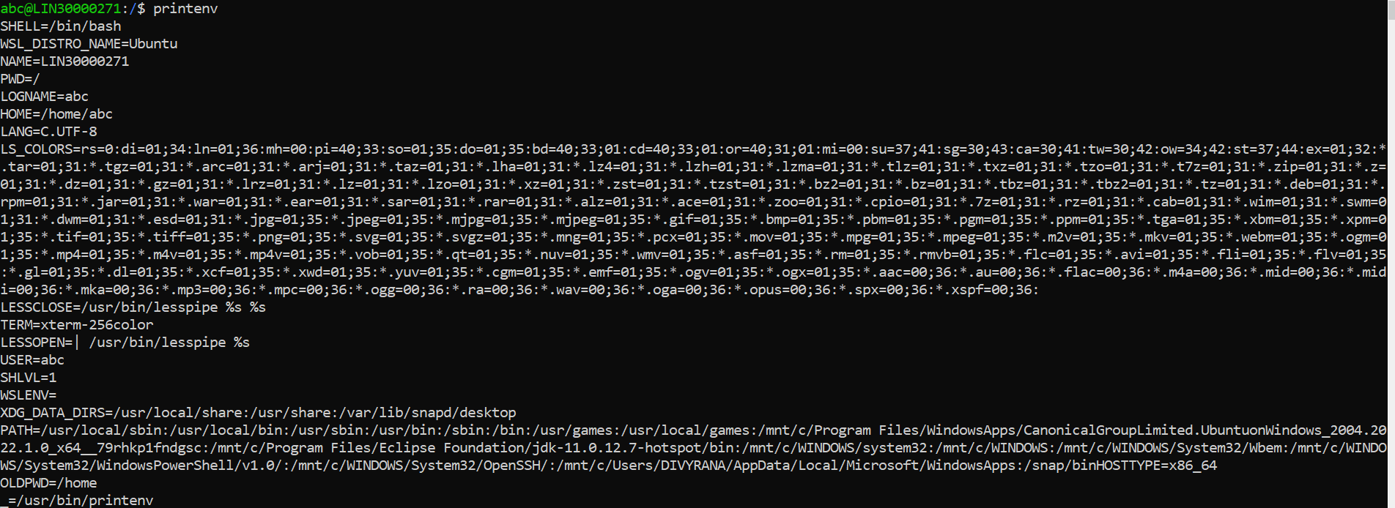
  - display the PATH environment variable value
Ans: echo $PATH
  - update PATH to include the path to your home directory
Ans:
path1=$PATH
PATH1=$PATH:$HOME
echo $PATH
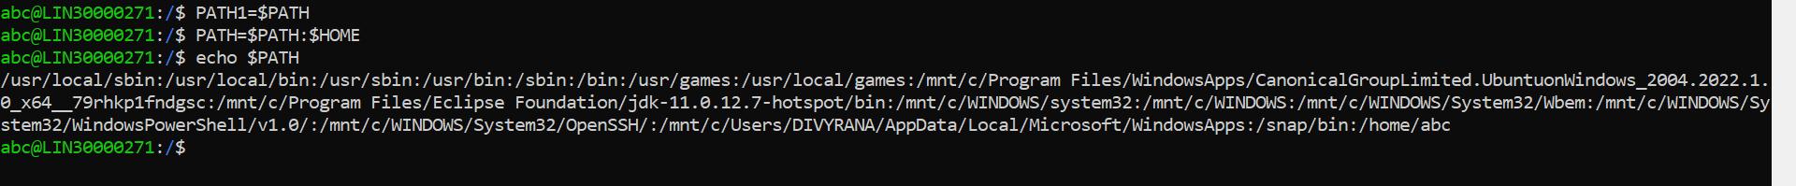
- How will you make the environment changes applicable to all users? Which script is to be modified?
Ans: .profile script is to be modified in order to make the environment changes applicable to all users.

- I have installed an application named “myapp”. After installation, if I invoke the application, it fails with error as “Command myapp not found”. How will you fix this?
Ans: In order to fix the error “Command myapp not found” in ubuntu, few steps can be used for resolving this erros:
- Making sure command is user’s path.
- Adding a new path to add new directory or the package “myapp”.
- Copying a file to existing path whenever the package is to be installed.

